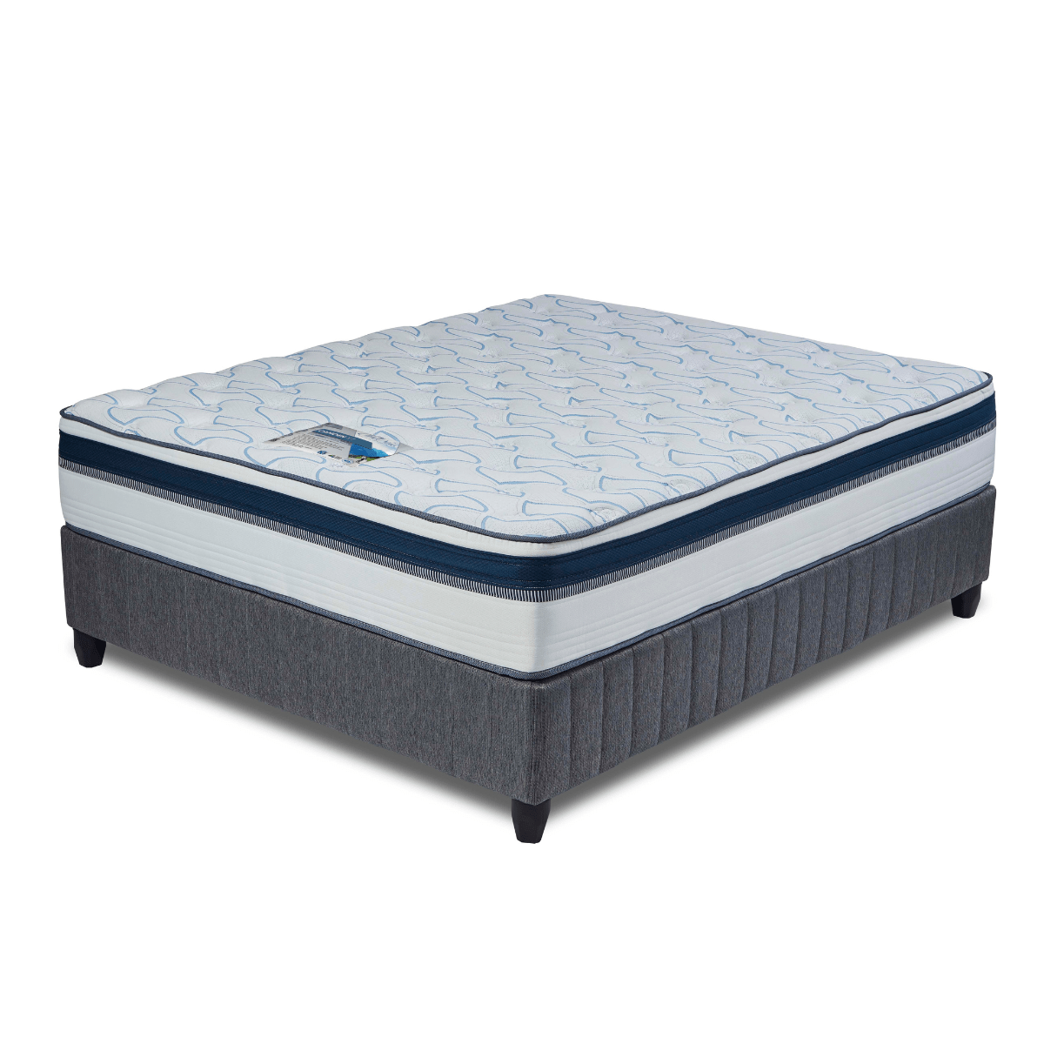


Model : Camden Bed Set
Supplier/Manufacturer : Cloud Nine
Range : Premium
Prices – Bed Set :
- Single Bed Set – R8879
- Three Quarter Bed Set – R10179
- Double Bed Set – R12429
- Queen Bed Set – R13609
- King Bed Set – R16969
Prices – Mattress Only :
- Single Mattress Only – R7219
- Three Quarter Mattress Only – R8339
- Double Mattress Only – R10399
- Queen Mattress Only – R11519
- King Mattress Only – R13659
Prices - Extra Length Bed Set :
- Single Extra Length Bed Set – R9589
- Three Quarter Extra Length Bed Set – R10999
- Double Extra Length Bed Set – R13429
- Queen Extra Length Bed Set – R14699
- King Extra Length Bed Set – R18329
Prices - Extra Length Mattress Only :
- Single Extra Length Mattress Only – R7799
- Three Quarter Extra Length Mattress Only – R9009
- Double Extra Length Mattress Only – R11229
- Queen Extra Length Mattress Only – R12439
- King Extra Length Mattress Only – R14749

*Please use this link for guideline for creating the page* - https://www.bedsonline.co.za/product/cloud-nine-camden-queen/
Cloud Nine Link - https://cloudnine.co.za/beds/premium/camden/

